Look And Feel Custom Specification

Introduction
A completed look and feel includes a set of component styles, such as button style, menu style, scrollbar style etc. Each component style consists of several states, which represent the appearance of the component in different states. For example, a button style can have the following states:
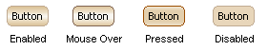
But please keep in mind that those states are not mandatory, they are omissible instead (if all states are omitted except the Enabled state, the component will show the same appearance at any state).

Recommended States List
In order to custom the look and feel, we should have all images for all states of all components. There are many possible combination of the component states, listing all the possibilities is not a good idea, so we provide a recommended list of the states for all components. In the following list, the recommended states are marked with “●”, it is recommended to provide the images for these states:
Component State: | Enabled | Mouse Over | Pressed | Disabled | Selected | Mouse Over & Selected
Buttons
Button | ● | ● | ● | ●
Arrow Button | ● | ● | ● | ●
Checkbox Button | ● | ● | ● | ● | ●
Radio Button | ● | ● | ● | ● | ●
Toggle Button | ● | ● | ● | ● | ●
Combo Box
Combo Box | ● |  |  | ●
Desktop & Internal Frame
Internal Frame 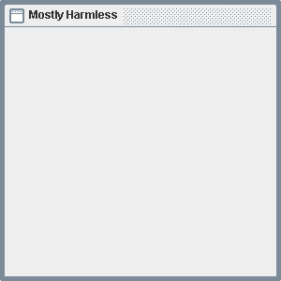 | ● |  |  | ●
Internal Frame Title Pane | ● |  |  | ●
Internal Frame Close Button | ● | ● | ● | ●
Internal Frame Minimize Button | ● | ● | ● | ●
Internal Frame Maximize Button | ● | ● | ● | ●
File Chooser
File Chooser 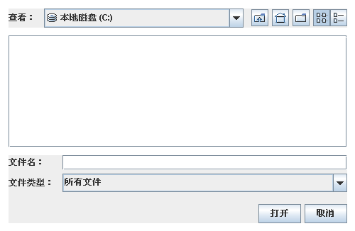 | ●
List
List 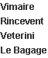 | ● |  |  | ● | ●
Menu
Menu Bar | ● |  |  | ●
Menu | ● |  |  | ● | ●
Menu Item | ● | ● |  | ●
Menu Item Accelerator | ●
Check Box Menu Item | ● | ● |  | ● | ● | ●
Radio Button Menu Item | ● | ● |  | ● | ● | ●
Popup Menu 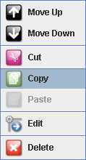 | ● |  |  | ● | ●
Popup Menu Separator | ● |  |  | ●
Option Pane
Option Pane 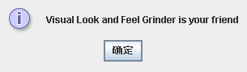 | ●
Progress Bar
Progress Bar | ● |  |  | ●
Scroll Bar & Scroll Pane
Scroll Bar | ●
Scroll Bar Track | ●
Scroll Bar Thumb | ●
Separator
Separator | ● |  |  | ●
Slider
Slider | ● |  |  | ●
Slider Track | ● |  |  | ●
Slider Thumb | ● |  |  | ●
Split Pane
Split Pane Divider 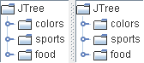 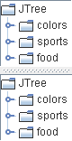 | ●
Table
Table 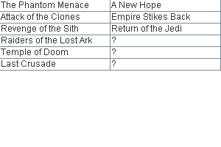 | ● |  |  | ●
Table Header | ● |  |  | ●
Tabs
Tabbed Pane Tab 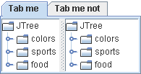 | ● |  |  | ● | ●
Text Display & Edit
Tool Tip | ● |  |  | ●
Text Field | ● |  |  | ●
Formatted Text Field | ● |  |  | ●
Password Field | ● |  |  | ●
Text Area 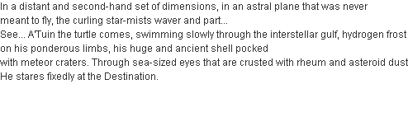 | ● |  |  | ●
Editor Pane | ● |  |  | ●
Tool Bar
Tool Bar 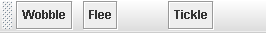 | ●
Tool Bar Drag Window | ●
Tree
Tree 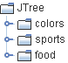 | ● |  |  | ●
Tree Cell | ● |  |  |  | ●

Requirements for Image Files
The image files for component states should meet the following requirements:
- Should be 1:1 scaling
- Lossless compress format, PNG is preferred.
- Transparent background (if applicable)

Should provide the images for up, left, right, down directions respectively
Can change the icons inside
Should provide icons for “Error”, “Warn”, “Info” and “Question” dialogs respectively
Should provide images for both horizontal and vertical progress bars
Should provide images for both horizontal and vertical scroll bars
Should provide images for both horizontal and vertical sliders
Should provide images for both horizontal and vertical split pane dividers

